|  |
| --- |
| **Emulating a TCP-Over-UDP Connection Using an ESP32 Dev Board**  CS 5283-50 Computer Networks  Team Members: Brian Goldsmith & Damon Raynor |

1. Purpose

The purpose of this project is to explore Wi-Fi data communication over the internet from one physical device (our personal CPU/laptop) to another (an ESP32 Development Board). Our main goals are to:

1. Visually demonstrate the TCP-over-UDP Handshake protocol.
2. Successfully send messages from one physical device to another over Wi-Fi.
3. Observe and capture the traceroute of relevant network traffic between the physical devices.

In order to meet our goals, we went through the process of procuring, programing and setting up an ESP32 Development board and ancillary electrical components (to aid in visualizing successful connections and transfers of data). The remainder of this report details (1) our approach to choosing and configuring our hardware setup, (2) programming the client and server comms channel, and (3) analyzing the results of our traceroute captures.

1. Project Description
   1. High level Project Architecture

This project consisted of communicating to an Arduino-like ESP32 Development board from a personal computer over Wi-Fi. The decision was made to assign the ESP32 board as the server that the personal computer would request a connection from. Table 1 identifies the network protocol suite that governs the project.

Table 1: Network Protocol Suite

|  |  |
| --- | --- |
| **Network Layer** | **Protocol** |
| Application | Custom (TCP-Like) |
| Transport | UDP |
| Network | IP |
| Link | Wi-Fi |

The custom application layer protocol was designed to ensure reliable data transfer over UDP via (1) implementing the TCP handshake protocol (reference Figure 1 for a visualization) (2) acknowledging receipt of packets sent and (3) implementing the TCP protocol for closing the connection after all information has been sent (reference Figure 2).

Figure 1: TCP Three-Way Handshake visualization

Figure 2: TCP Closing Connection Visualization

* 1. Verification Strategy

To verify that the application worked as intended, (1) the ESP32 Development board was outfitted with two LED light bulbs and programmed to turn the LEDs on and off to visualize the establishment and closing of a connection, (2) the client and server side of the application was programmed to print their respective status to the terminal, and (3) the network monitoring software, Wireshark, was used to trace the communication between the two devices. Figure 3 defines the expected behavior of each LED to visualize each step of the communication process.

|  |  |  |  |
| --- | --- | --- | --- |
| **Step** | **Server Connection State** | **LED 1 State** | **LED 2 State** |
| **0** | No Connection | Off | Off |
| **1** | LISTEN | Blinking | Off |
| **2** | SYN RCVD  (Handshake Initiated) | Steady | Off |
| **3** | ESTAB  (Connection Established) | Steady | Steady |
| **4** | Receiving Message | Steady | Off |
| **5** | CLOSE WAIT | Off | Blinking |
| **6** | CLOSED | Off | Off |

Figure 3: LED State Representation of the Communication Process

Refer to section 3 for a detailed description of the hardware setup, section 4 for the application code architecture and section 5 for the conclusion, code outputs received and Wireshark traces captured.

1. Embedded Device Description and Setup
   1. ESP32 Development Board High Level Overview

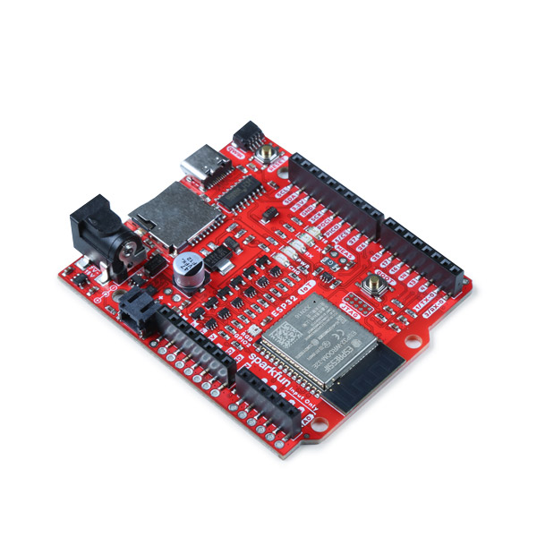

Figure 4: ESP32 Development Board

According to the manufacturer, ‘the SparkFun IoT RedBoard is an ESP32 Development Board that includes Espressif's ESP32 WROOM, Wi-Fi and Bluetooth® MCU module that targets a wide variety of applications. At the core of this module is the ESP32-D0WDQ6 chip which is designed to be both scalable and adaptive. The IoT RedBoard can target a wide variety of applications, ranging from low-power sensor networks to the most demanding tasks, such as voice encoding, music streaming, and MP3 decoding.’

This board was chosen primarily for its Wi-Fi capabilities and affordable price point. The following link routes to the website where you can purchase this board and read more about its specifications and potential use cases: [SparkFun IoT RedBoard - ESP32 Development Board - WRL-19177 - SparkFun Electronics](https://www.sparkfun.com/products/19177)

This ESP32 board is powered and programmed via a USB to USB-C cable. The Arduino IDE was used for writing and uploading code to the ESP32. The Arduino Programming Language was necessary to properly program the board – which is basically a framework built on top of C++.

Once powered, this board and other Arduino-like boards run continuously on a loop of whatever has been uploaded to it. The programming structure to support this generally consists of two sections/functions: (1) **setup()** and (2) **loop()**. When powered, the board will initially run **setup()** only once, and then will continuously loop though the **loop()** function. It is necessary to plan how you will execute your program within this programming structure. Section 4 details the application code architecture for this project.

* 1. Hardware Setup and Circuit Layout

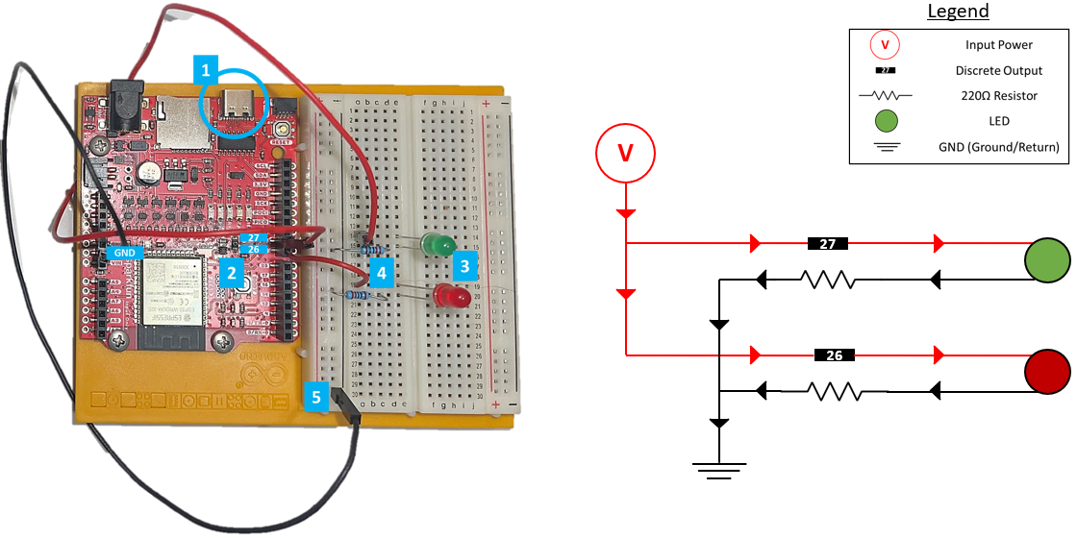

Figure 5: Hardware Setup and Circuit Layout

Figure 5 shows the hardware setup and circuit layout used for this project. Our hardware consisted of the following components:

* (1) ESP32 Development Board
* (1) Circuit Bread Board
* (2) LEDs
* (2) 220Ω Resistors
* (3) Wires

Referencing the blue numerical indicators depicted in Figure 5, power comes through the USB-C port (1), outputs 3.3V at discrete outputs ‘26’ and ‘27’ (2), which is directed to the LEDs – each discrete output controls one LED – (3), then is reduced by a 220Ω resistor (4), and finally grounded to complete the circuit (5).

There are a total of two circuits. Each circuit shares the same power source, has one discrete output, one LED, one resistor and shares a common ground. Figure 5 also shows a simplified schematic of each circuit. The red lines/arrows represent the power input path while the black lines/arrows represent the return path.

This setup was inspired by the following tutorial: [ESP32 Web Server - Arduino IDE | Random Nerd Tutorials](https://randomnerdtutorials.com/esp32-web-server-arduino-ide/)

1. Application Code Architecture

For the ESP32 board, the Arduino IDE is used to write and transmit the code to the board. The Arduino IDE uses a C++ variant with a number of methods specific for the Arduino environment. The Arduino IDE also includes a Serial Monitor which allows for communication to and from the ESP32 board while it is connected via USB.

Since the Programming Assignment 2 code was in Python, there was significant effort to translate the code into the C++ variant.  A number of helper functions were written with some matching utilities provided in Programming Assignment 2 and others specific to the Arduino hardware. For example, to match some of the utilities functionality, functions were written to update the server state and also cleanly print packets that are received. For the ESP32 board, the helper functions included functions to set the LEDs to turn on, off, and blink, as well as to read a character from the Serial Monitor.

The standard Arduino sketch, which is the name for the code file, contains a setup function and a loop function. The setup function sets the initial configuration for the board while the loop function runs continuously while the board is powered. For the project, the setup function connects to a designated wireless network and obtains an IP address. After successfully obtaining the IP address, the setup function then starts the UDP server. The loop function contains the main logic for this project including the state machine of the UDP server with the states CLOSED, LISTEN, SYN_RECEIVED, ESTABLISHED, CLOSE_WAIT, and LAST_ACK.

The UDP server starts in the CLOSED state. When the CLOSED state is detected, the UDP server updates the state to LISTEN which is the default state of the UDP server. In the LISTEN state, the ESP32 board sets the LED attached to pin 26 to blink. Also, the UDP server is listening for incoming packets to the server, as well as any incoming characters from the Serial Monitor of the Arduino IDE. If an incoming packet is detected, it is printed to the Serial Monitor and the SYN flag of the packet header is checked. If the SYN flag is set to 1, a response is generated with a header that includes a new random sequence number, an acknowledge number incremented by 1, and the SYN and ACK flags set to 1. The packet is then printed to the Serial Monitor and sent to the client. Finally, the state of the UDP server is updated to SYN_RECEIVED. In the SYN_RECEIVED state, the LED attached to pin 26 is set to ON to show that the server received an incoming packet and a connection is being established. The SYN_RECEIVED state then looks for an incoming packet with a header that has the ACK flag set to 1. If that is received, then the UDP server prints the incoming packet and updates the server state to ESTABLISHED.

In the ESTABLISHED state, the LED attached to pin 27 is set to ON showing that the connection has been established and the UDP server is ready to receive data. The UDP server then looks for incoming packets and checks if data is being sent or if the client is starting to close the connection by setting the FIN flag in the header to 1. If data is received, the packet is printed in the Serial Monitor and the data is saved to a string buffer in case the message is long and needs to be broken into multiple packets. A response is generated, printed in the Serial Monitor, and sent to the client with the appropriate sequence and acknowledge numbers and with the ACK flag set to 1. If the FIN flag in the header from the client is received, the UDP server prints the incoming packet. It then creates a response header with the correct sequence and acknowledge numbers and the ACK flag set to 1. Finally, the UDP server prints the packet, sends the packet to the client, and sets the server state to CLOSE_WAIT which changes the LED attached to pin 27 to blinking. In the CLOSE_WAIT state, the UDP server builds a packet header with the valid sequence and acknowledge numbers and the ACK and FIN flags set to 1. The UDP server prints the packet in the Serial Monitor and then sends the packet to the client before updating the server state to LAST_ACK. In LAST_ACK, the UDP server waits for a final response from the client with an ACK flag set to 1. When this is received, the packet is printed and the server is set to CLOSED which turns off the LEDs on both pin 26 and 27.

Since the UDP server is able to quickly establish and terminate connections, it is difficult to see the different transitions in the LEDs. In order to assist in visualizing the changes delays can be implemented if a delay flag is set to true. By default this flag is set to false, however sending a one, 1, from the Serial Monitor to the ESP32 board when the UDP server is in state LISTEN will set the delay flag to true. Sending a zero, 0, from the Serial Monitor sets the delay flag to false. The delays are implemented after changing to the SYN_RECEIVED state, the ESTABLISHED state, and the CLOSE_WAIT state.

1. Project Results
   1. Conclusion

By way of our verification strategy, we were able to successfully meet our goals as outlined in section 1.

1. We were able to visually demonstrate our intended communication process via controlling the two LEDs as described in section 2.2.
2. The terminals for both the client and server-side displayed the expected output which identified that a connection was established, a message was broken up, sent in packets, and correctly reassembled. See section 5.2 for the client and server printouts.
3. Wireshark properly detected and reported on the activity between both devices. Section 5.3 contains the Wireshark log file that shows communication between both devices.
   1. Expected Client and Server Terminal Outputs

Attached to this report are the client and server logs outputted after establishing a connection, sending the message *“It was the best of times, it was the worst of times, it was the age of wisdom, it was the age of foolishness”*, and closing the connection.

|  |  |
| --- | --- |
| **Client Logs** | **Server Logs** |
|  |  |

Using Figure 6 as an example, we can confirm that (1) a Wi-Fi connection was established, (2) that the handshake protocol was a success, and (3) that packets containing the message has begun to be received. Reviewing the Client Logs will reveal that the server properly acknowledges that packets have been received and that the connection closes properly.

Figure 6: Server Logs Snippet

* 1. Observed Network Traffic

Attached is the Wireshark capture log associated with the communication from our personal computer to the ESP32 Board. The IP address for the computer is 192.168.1.11 and the IP address for the ESP32 Board is 192.168.1.33. Figure 7 shows the results when filtering on “ip.addr == 192.168.1.33”. This confirms communication between both devices.

|  |
| --- |
| **Wireshark Logs** |
|  |

Figure 7: Wireshark Logs Filtering on “ip.addr == 192.168.1.33”